Sanitise the Product Claim

By Sarah Wade
Software Developer Level 4
BGL Group

My team is involved in the support and maintenance of the sales journey for car insurance. A bug was identified in a product which was already in the ‘deployed’ stage of the software lifecycle. This means that the bug is a live bug, which is effecting customers and therefore as part of the maintenance phase, needed fixing immediately.
My company identified a live bug that effected certain customers during their sales journey which would cause an error page and prevent the customer from completing. This bug was identified as revolving around different string cases being passed through, primarily involving a variable called product. I was assigned the ticket with the requirement to make the journey cases insensitive so that errors would not occur. Currently if the product Id gets passed in from a URL so occasionally comes through with mixed capitalisation, for example Car instead of car. This was causing the following error page when users continued further into their sales journey (fig 1):
Fig 1, Error page
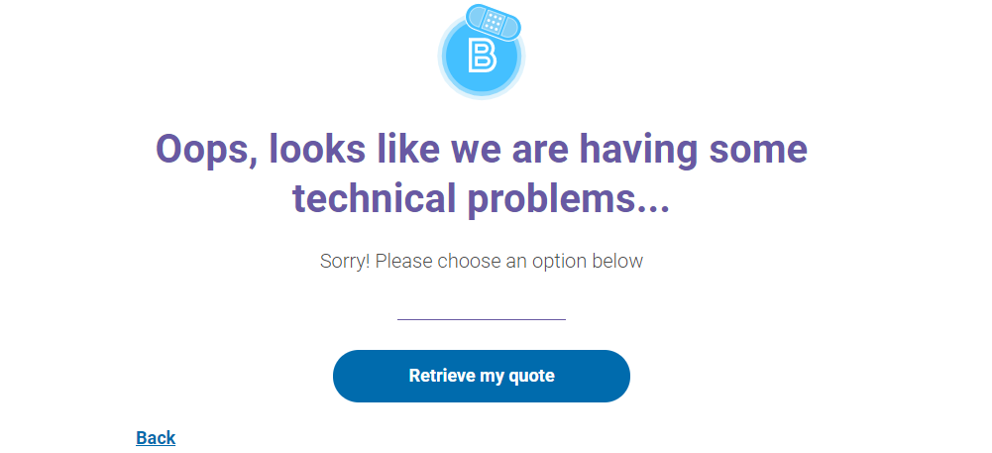

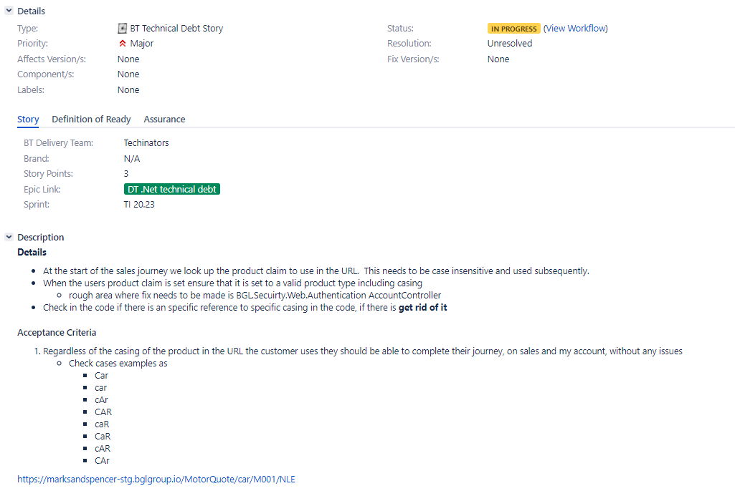
Which would cause a frustrating experience, and potentially interrupting sales if the customer did not reattempt. My task was to fix this bug and ensure the process was case insensitive, update the corresponding tests. Once fixed I would need to complete the QA and DA review and complete a pull request. Ensuring that in Team City(my company’s deployment platform) the build runs and passes. Below is the jira ticket created for this issue (fig 2):
Fig 2: Jira Ticket

I began by looking through the existing code and following the product I’d journey. I spent time investigating this and deciding where was best to make the change to make the product Id able to be any type of casing. I followed the product I’d journey until it was passed into a method within IdentityHelper.cs. This file contained a method called GetBaseClaims, which as its name suggests was responsible for returning a list of the claim constants as a list of claims. This method took in the product Id as one of its parameters and assigned it to a Claim type (as see in fig 3).
Fig 3: Product Id passed into the Claim type
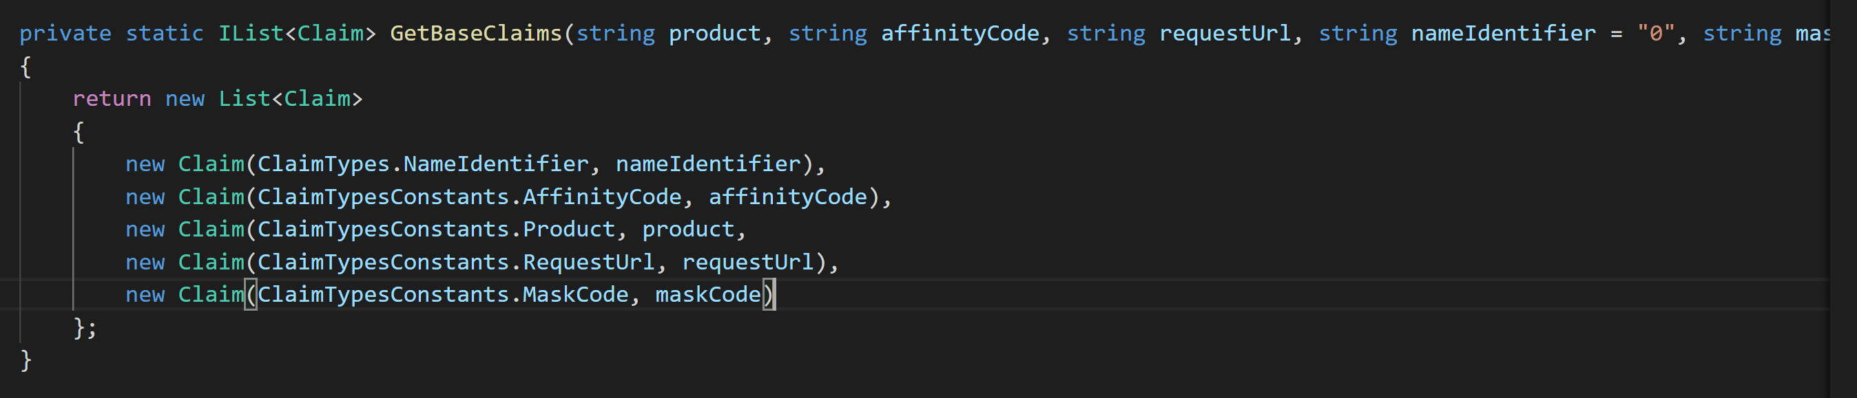

This was a good place to ensure that the product Id being passed in was the correct casing format. Rather than adding extensive filters to format the incoming product string, instead I chose to use ‘ToTitleCase’ (fig 4). I added this to the product.
Fig 4: To Title Case
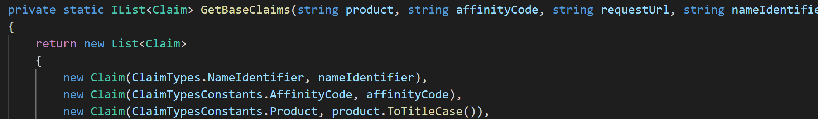

This is an internal method that format the string to the current ‘culture’ outlined by my company. In this case and string would have a capital letter at the beginning of the string and the rest lowercase. This met the requirements of this ticket and would ensure that all product I’d passed in would be formatted this way, which is recognisable by all the connecting methods.
I then added the using statement that would allow ToTitleCase() to be accessed (fig 5).
Fig 5: Using Statement

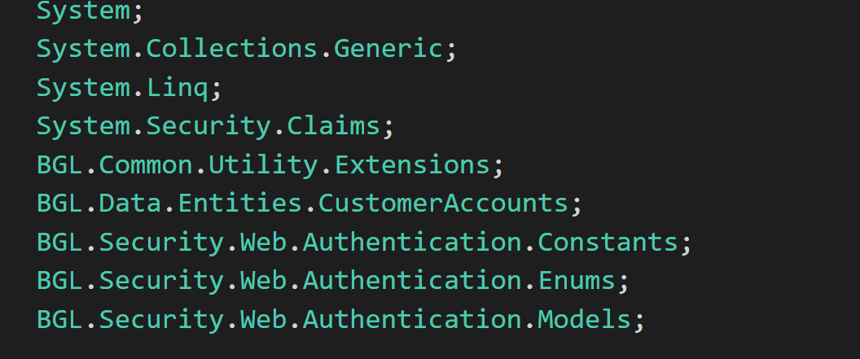

As stated this should fix the issue with the casing bugs. My next step was to update the unit tests to reflect this. Usually our company prefer developers to TDD. However, when applying fixes to bugs its best practice is to correct the tests after and then submit a pull request so that work is properly reviewed.
I navigated into the existing test files and altered the test cases. At present the test cases passed in only lower-case product Id’s, which is what should have been passed in before. Now however the tests would need to ensure that any casing that was passed in would not cause any problems. In the expected results on various separate tests I altered the Product constant (see fig 5) and changed the casing to a number of different formats, for example fig 6.
Fig 5: Product Constant before changes fChanges
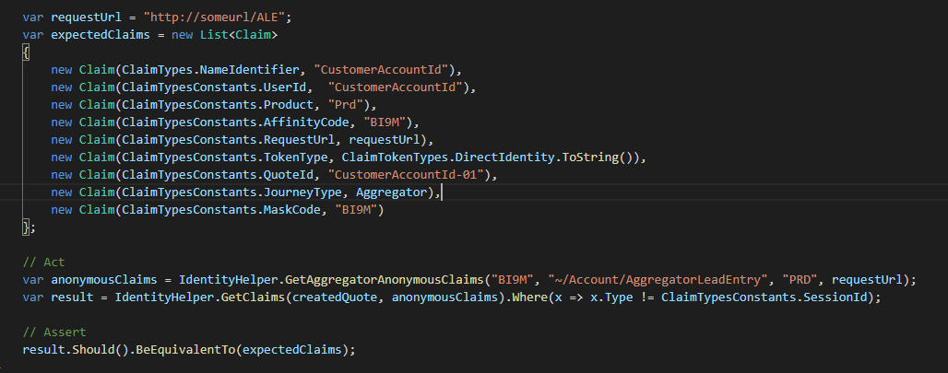
Fig 6: Changes made to result

This concluded the changes that I believed would fix the issue. The tests passed and ran green so I submitted a pull request to a senior member of the team who reviewed the code (fig 7). As this is a live bug a pull request is important, mainly to identify that the work completed sufficiently met the goals of the initial ticket. But also, to ensure that changes made would not break other features in live.
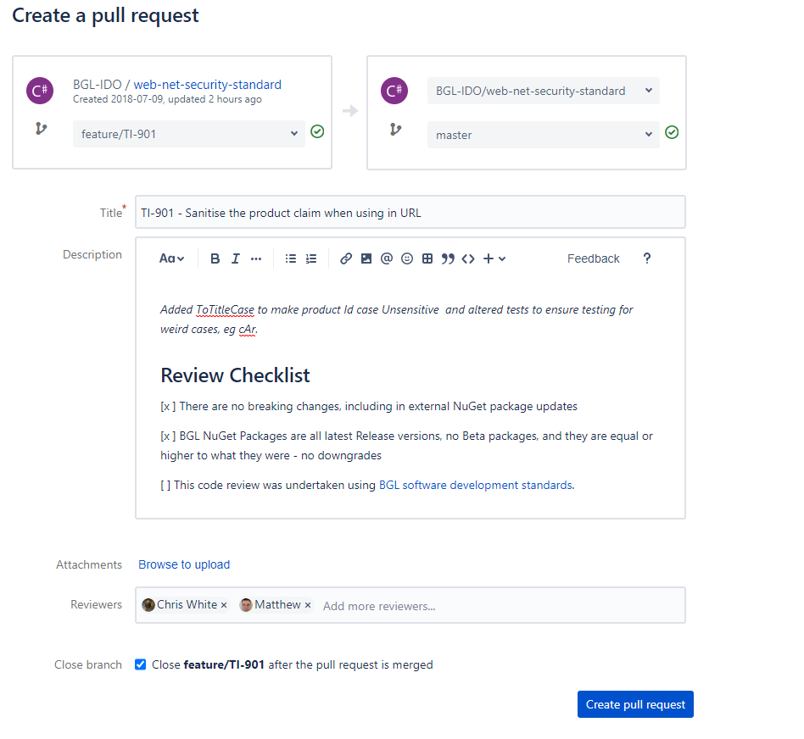
Fig 7: Pull Request

As you can see from my attached screenshot my company has strict policies for deploying code back into live. I had to complete a pull request, merge the code only after the pull request had been reviewed and then ensure that the solution built correctly in Team City. Team City would check that it built correctly and passed all tests automatically.
Fig 8: Approved Pull Request
My pull request was approved. 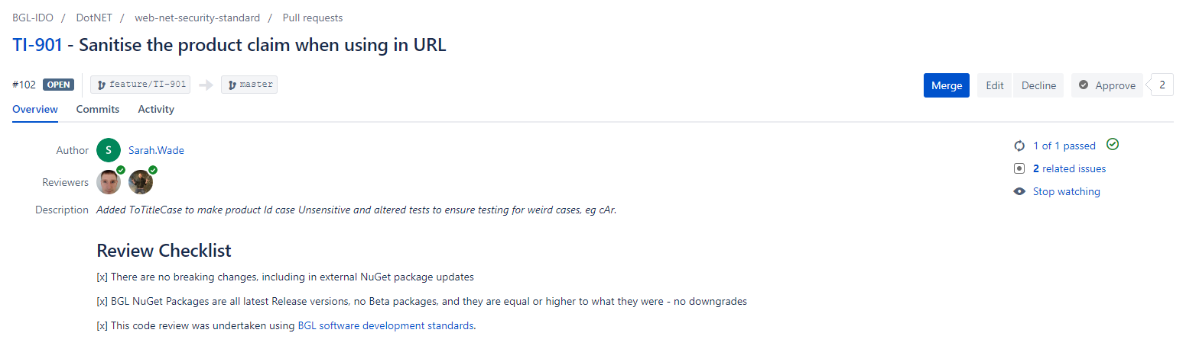
I merged my work in the live version and manually tested the customer journey, deliberately entering in the product Id into the query string as ‘cAr’ to test that my changes were effective. The result was I could move onto the correct page and continue to enter their details, meaning my changes were a success and prevented the error page noted earlier (fig. 9).
Fig 9: Final outcome, fixed page
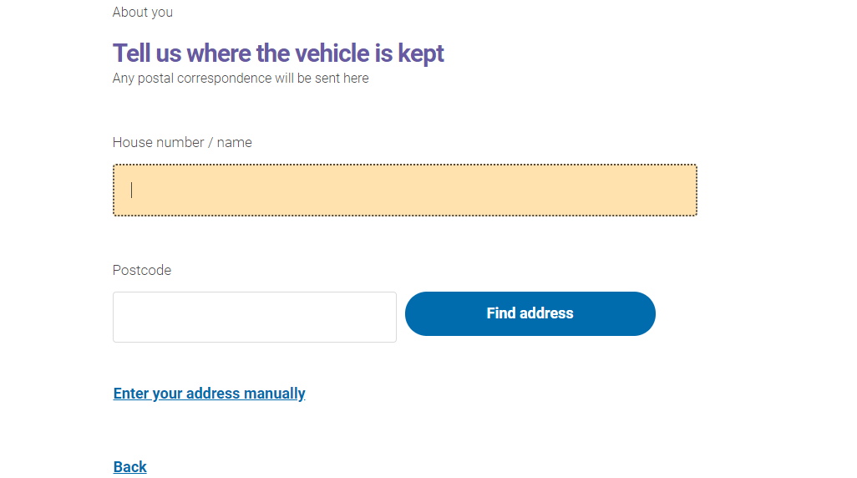

Conclusion
The work completed met the outlined requirements and enabled customers to complete their sales journey without experiencing a frustrating error. The ticket outlined a suggestion to format the product Id, which I essentially did in just one place that would be used throughout the code. This prevented repetition, as I didn’t change the Id casing in multiple locations. I adhered strongly to my company process for live deployment bugs ensuring that the code that I pushed and eventually merged into the live version was sound and with tests that supported it. This change completely satisfied the requirements for this bug, enabling any casing to be passed in without causing further errors.

